Encoding/Decoding Website
Software Requirements Specification
Published: November 12, 2020
Updated: N/A
This document is available under the GNU Affero General Public License v3.0

Table of Contents
Purpose 3
Intended Audience and Use 3
Scope 3
Definitions 3
System Overview 3
References 3
Overall Description 3
User Stories 4
Assumptions/Dependencies 4
Flowcharts 5
Functional Requirements 7
External Interface Requirements 9
System/Software Requirements 9
Performance Requirements 9
Quality 9
Layouts 9

Purpose
The main purpose of a website is to deliver valuable information in a tight format that is easy to read and digest. The purpose of open-source software is to deliver functionality while freeing the users from the constraints imposed on usage and modification found under current copyright law. The purpose of this website is to combine these two concepts.

Intended Audience and Use
The audience for this SRS are developers and testers. This document should be used as a framework for developing and testing the Encoding/Decoding website.

Scope
The Encoding/Decoding website is a blog that is available under the GNU Affero General Public License v3.0. The primary objective is to catalog technical information for later reference. The secondary objective is to build a template for other websites.

Due to the constraints of hosting a static website on Github, this SRS will not cover any requirements related to dynamic websites, including server-side programming or server-based databases.

Definitions
- TBD

System Overview
- TBD

References
- https://www.joelonsoftware.com/whattimeisit/
- https://en.wikipedia.org/wiki/Software_requirements_specification
- https://relevant.software/blog/software-requirements-specification-srs-document/#A_Software_Requirement_Specification_(SRS)_Example
- https://www.perforce.com/blog/alm/how-write-software-requirements-specification-srs-document

Overall Description
Encoding/Decoding is a blog that explores the technical aspects of various technologies and how they are used in the context of projects found on the Github profile managed by Eric Stenberg.

This requirements specification is available under the GNU Affero General Public License v3.0.

This specification is an ongoing work and will never be considered complete. This specification will be updated to accommodate new features and to clarify current requirements with clearer language.

User Stories
Scenario 1: Jim
Jim is a novice software developer and tester. He uses programming to automate repetitive tasks and analyze data. He is learning new technologies and completing projects using those technologies to deepen his understanding of data analysis, data science, computer science, and software engineering. Encoding/Decoding allows him to catalog his work for future reference.

Scenario 2: Dan
Dan is a web developer. He is developing a website and is looking for templates to quickly incorporate into his design. Dan wants to use an open-source template to modify and distribute as his own, and to ensure that any design he creates or forks is not incorporated into another product without maintaining that open-source license for downstream users.

Assumptions/Dependencies
- Encoding/Decoding will be a static website
- The website will be hosted on Github
- The website will be available under the GNU Affero General Public License v3.0.
- Development Tools
  - Text editor (i.e. Notepad++ or equivalent)
  - Web server solution stack (i.e. XAMPP or equivalent)
  - Version-control system (i.e. Git for Windows or equivalent)
  - Command-line interface (i.e. Command Prompt or equivalent)
  - Stylesheet language (i.e. SASS or equivalent)

Flowcharts
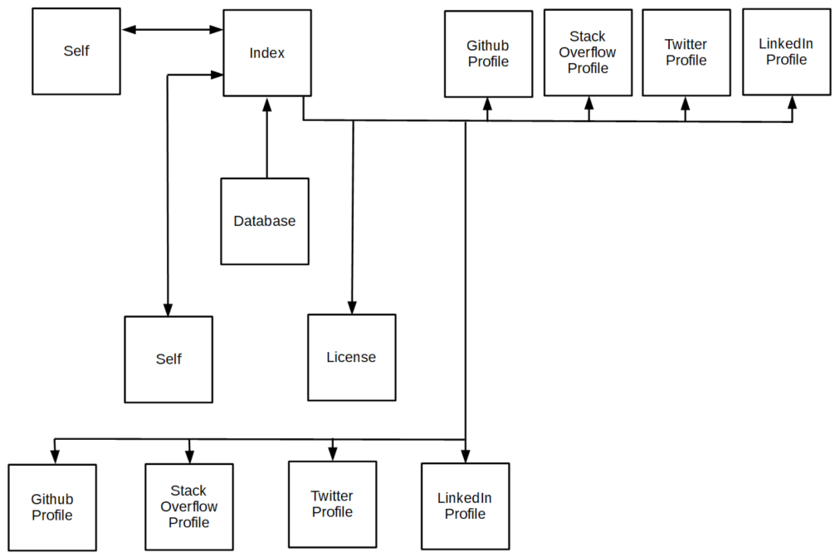
Figure 1. Index Page Flowchart
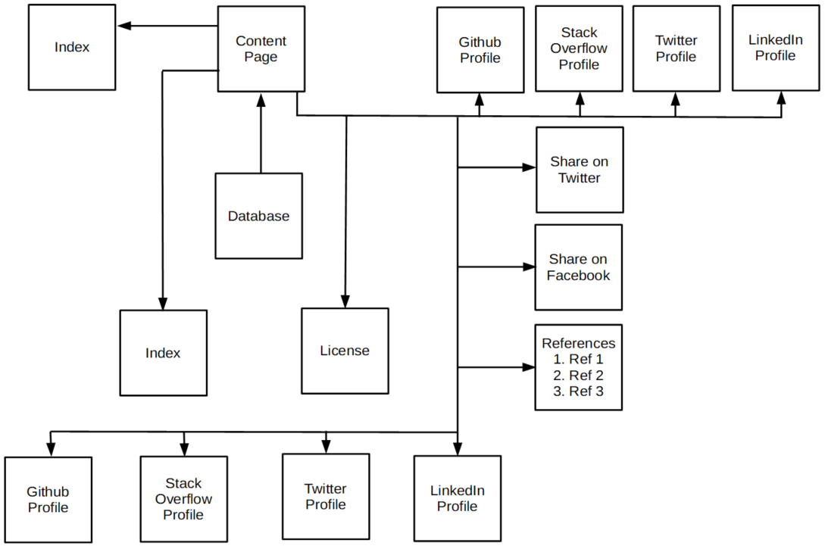
Figure 2. Content Page Flowchart

Functional Requirements
- Index
  - Header
    - Text “Encoding/Decoding” at top of the page that is also a link to the Index page
    - Header “Networking Links” to the left of the links
    - Link to Github profile
    - Link to Stack Overflow profile
    - Link to Twitter profile
    - Link to LinkedIn profile
  - Body
    - Left Column
      - Header with the title “Latest Posts”
      - Links to ten of the most recent posts sorted in descending order by publishing date
    - Center Column
      - The most recent posts sorted in descending order with the following information:
        - Content title
        - Published date
        - Updated date
        - Content summary
    - Right Column
      - This column contains nothing
  - Footer
    - Link to Index page
    - Link to License
    - Link to Github profile
    - Link to Stack Overflow profile
    - Link to Twitter profile
    - Link to LinkedIn profile
    - Text: “This page is available under the GNU Affero General Public License v3.0”
- Content
  - Header
    - Text “Encoding/Decoding” at top of the page that is also a link to the Index page
    - Header “Networking Links” to the left of the links
    - Link to Github profile
    - Link to Stack Overflow profile
    - Link to Twitter profile
    - Link to LinkedIn profile
  - Body
    - Left Column
      - Header with text: “Adjacent Posts”
      - Links and publish dates to 4 recent posts published after the page
      - Links and publish dates to 4 recent posts published before this page
    - Center Column
      - Data pulled from JSON file:
        - Content title
        - Published date
        - Updated date
        - Repository link
      - Content with the following format:
        - Introduction
        - Content
          - Headers
          - Subheaders
          - Text
        - Tags
        - References
    - Right Column
      - Header with text: “Share this post!”
      - Link to share the current page on Twitter
      - Link to share the current page on Facebook
  - Footer
    - Link to Index page
    - Link to License
    - Link to Github profile
    - Link to Stack Overflow profile
    - Link to Twitter profile
    - Link to LinkedIn profile
    - Text: “This page is available under the GNU Affero General Public License v3.0”

External Interface Requirements
- The following links must work:
  - Github
  - Stack Overflow
  - Twitter
  - LinkedIn

System/Software Requirements
- Internet connection
- Browser
  - Mozilla Firefox
  - Microsoft Edge
  - Opera
  - Safari

Performance Requirements
- TBD

Quality
- TBD

Layouts
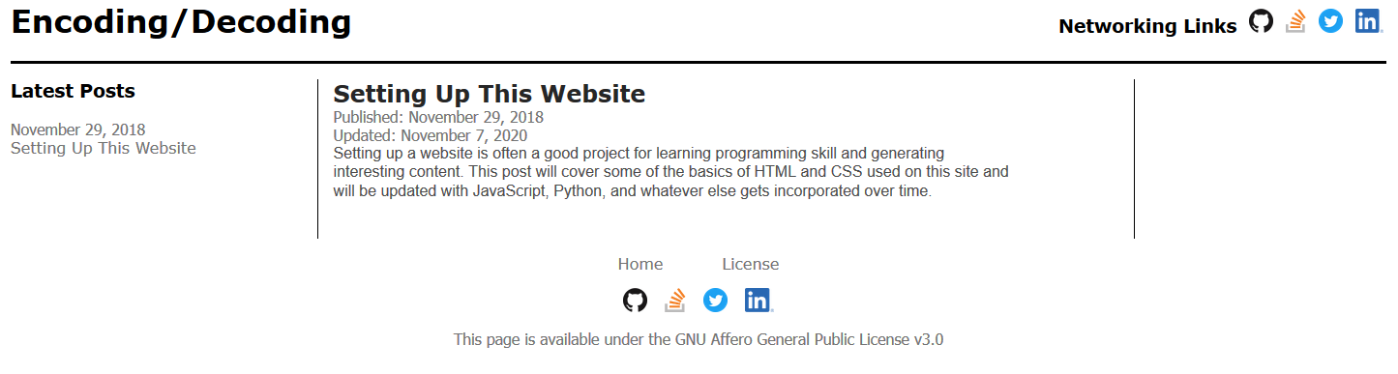
Figure 3. Index Page

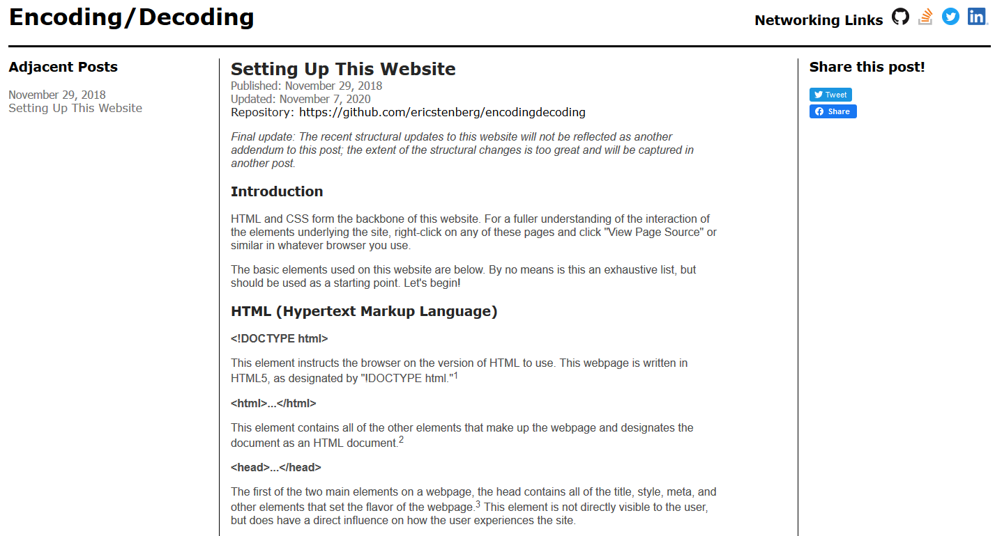
Figure 4. Content Page (Top)

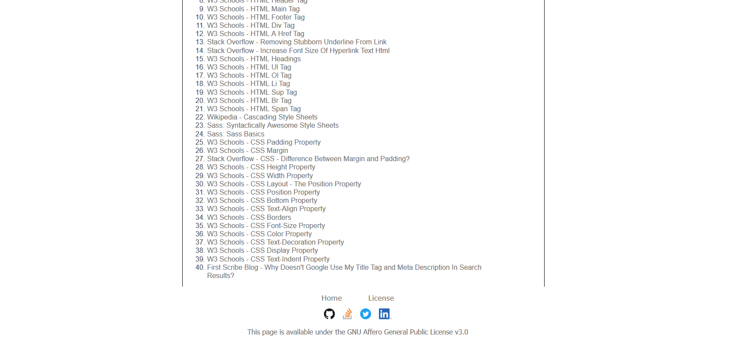
Figure 5. Content Page (Bottom)

